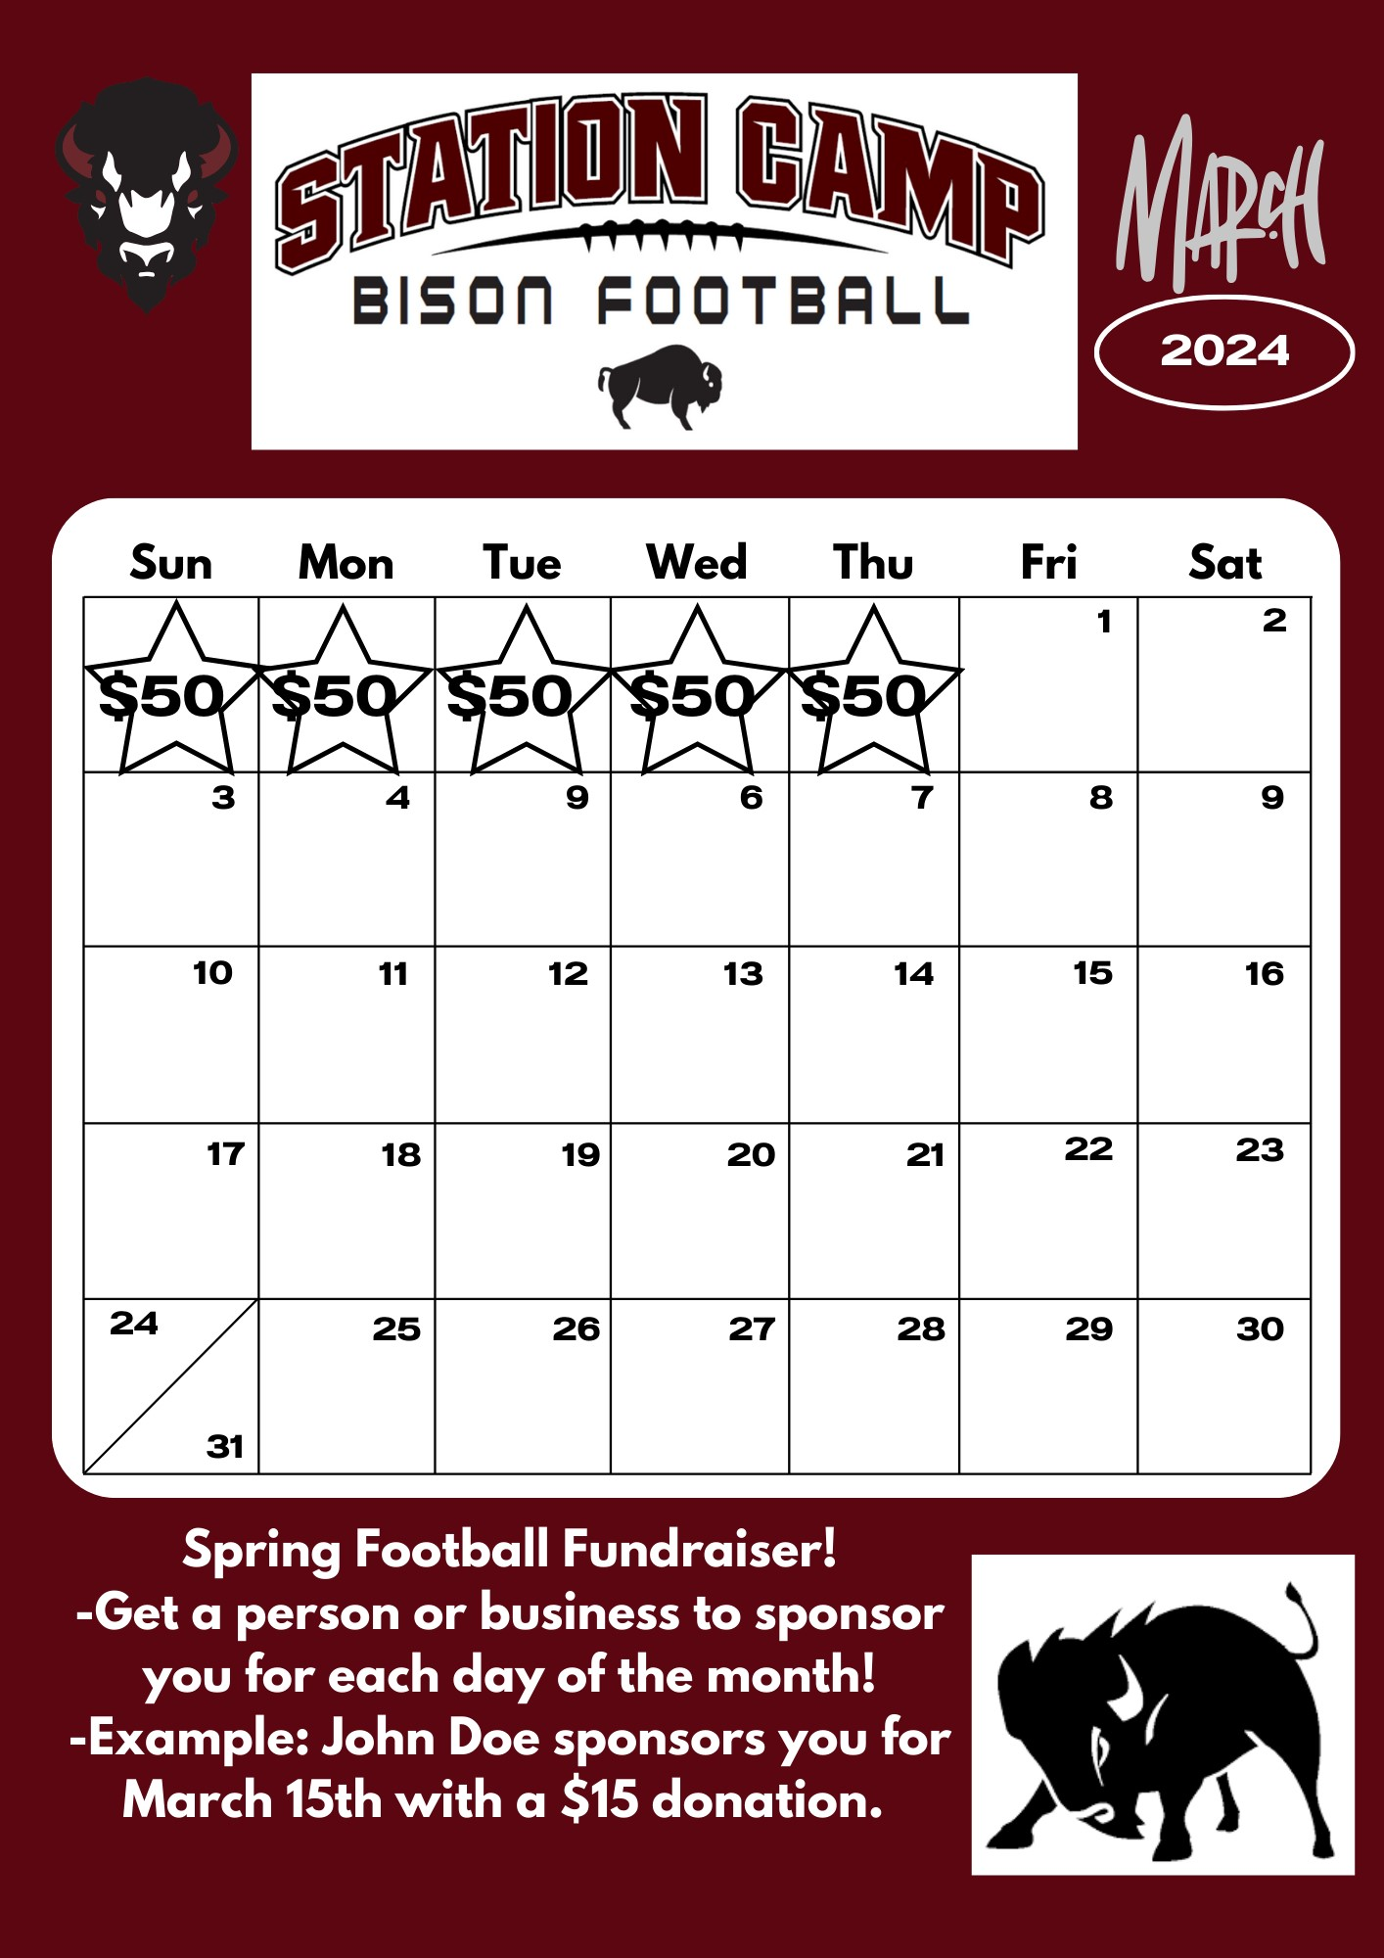

Fundraiser Details:

Individual Goals
- $450 (July 12th Requirement) – Apparel Pack, Team Meals, Game Socks, Officials, Equipment upkeep, Field Maintenance, Assistant Coaches, etc.
- $800 – Season Passes to home games for family of 6 ($120 value)
- $1,200 – Keep Helmet at end of year. (Helmets are currently $450 value)
- Jersey number selection based on total amount turned in for Spring Fundraiser!

Team Rewards for Spring Fundraiser
- $16,000 – New Black and White Jerseys and pants
- $22,000 – New Black and White Jerseys and Custom Player Apparel with Names/Team Logo
2024 Business Sponsorship Opportunities
- Game Sponsor – $150 per game (Sponsor name will be announced before game and after every quarter as official game sponsor – no limit to the number of sponsors per game)
***3 or more games sponsored will get a banner hung as well
- 1st down Sponsor - $250 per game
  - Business announced every first down along with banner hung throughout the season at the HS Stadium. Banner will be hung for the duration of the high school football season.
- Touchdown Sponsor - $250 per game
  - Business announced every touchdown along with banner hung throughout the season at the HS Stadium. Banner will be hung for the duration of the high school football season.
- Banner Sponsorship - $500
  - Banner hung throughout the season at the HS Stadium. Banner will be hung for the duration of the high school football season.

